**Asynchronous code**

Asynchronous code has events that are independent of the main program flow and are outside the program’s main thread.

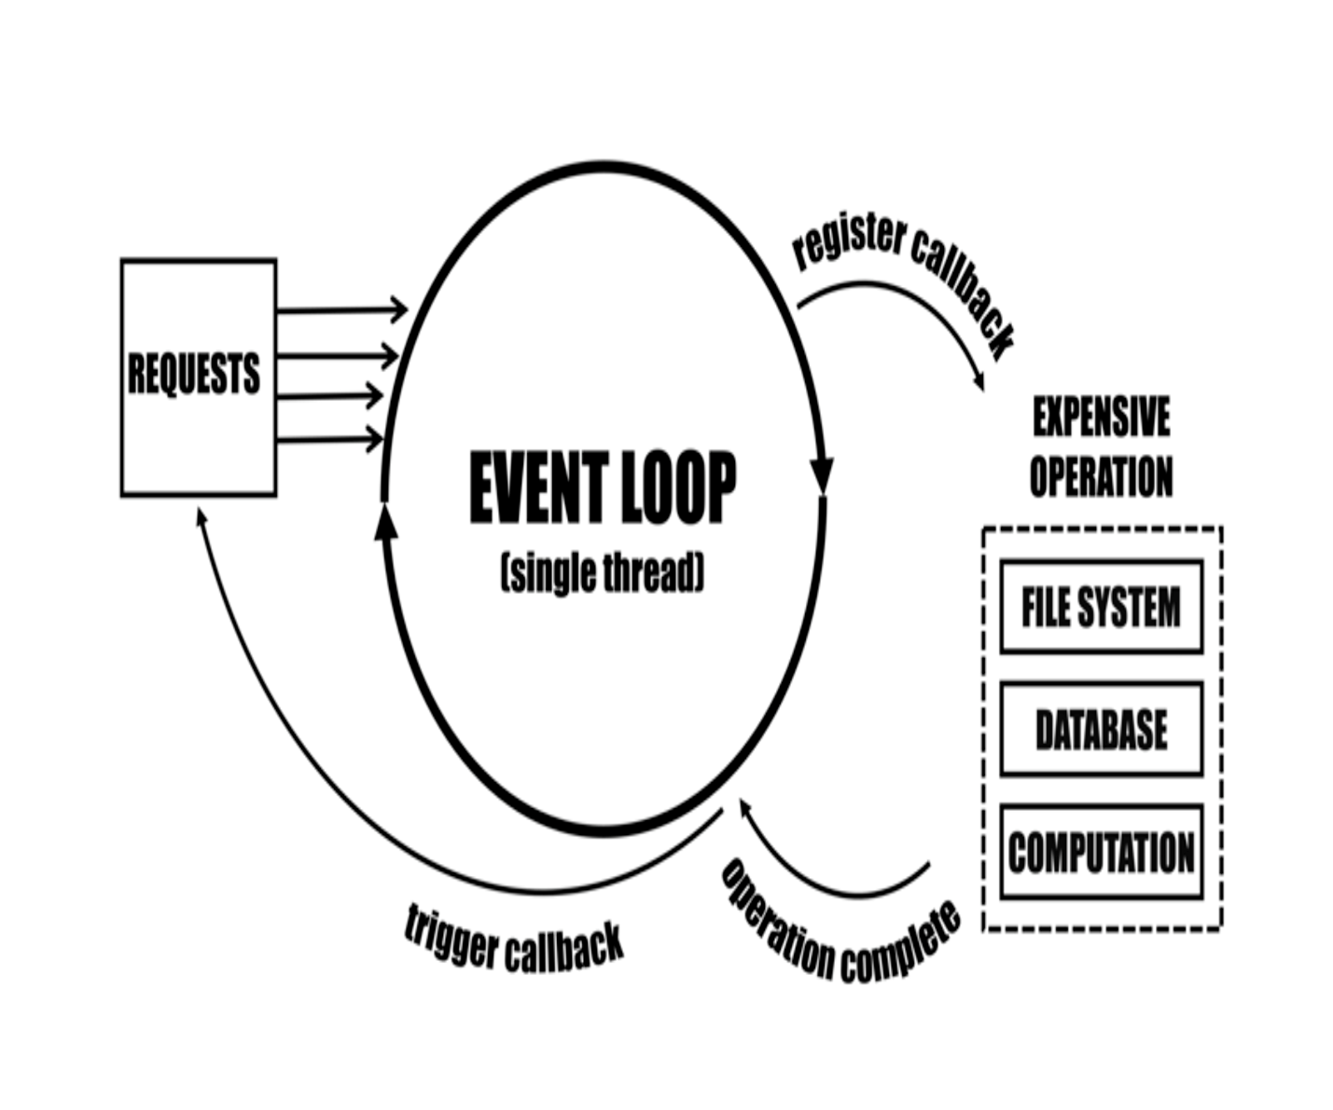

Here's a simple example.

/*

This code has an asynchronous setTimeout event

running outside the main program's event loop

*/

function first() {

setTimeout(function() {

console.log('the timer is done running outside the main event loop now!');

}, 2000);

return 'first'

};

function second() {

return 'second'

}

function third() {

return 'third'

}

console.log(first());

console.log(second());

console.log(third());

>

first

second

third

undefined

the timer is done running outside the main event loop now!

**Promises**

A promise object represents the eventual completion, or failure, of an asynchronous operation, and its resulting value.

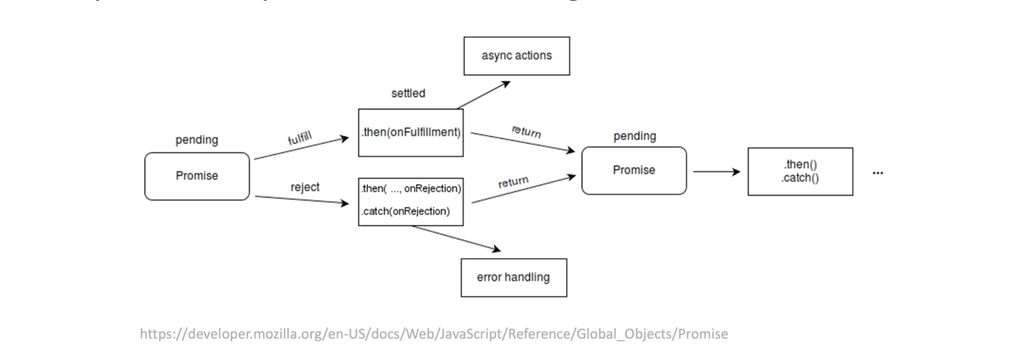

Here's a simple example.

//You promise to do your laundry

//this promise is either resolved or rejected

let p = new Promise((resolve, reject) => {

let laundryDone = false

if (laundryDone==true) {

//resolve the promise here

resolve('Success')

} else {

//reject the promise here

reject('Failed')

}

})

//Do something else after the promise resolves w/ .then

//Do something w/ error w/ .catch

p.then((message) => {

console.log('This message is in the .then: ' + message)

}).catch((message) => {

console.log('This message is in the .catch: ' + message)

})

>> This message is in the .catch: Failed

**Async and await**

Async functions are "syntactic sugar" (aka, cleaner, shorthanded syntax) to return and handle promises, that avoid messy nested promise chains.

Here's a simple example.

function resolveAfter3Seconds() {

return new Promise(resolve => {

setTimeout(()=> {

resolve('resolved');

}, 3000);

});

}

async function asyncCall() {

console.log('Calling now!');

const result = await resolveAfter3Seconds();

console.log(result);

}

asyncCall();

>>Calling now! //asyncCall awaits the callback function resolveAfter3Seconds

>>Promise {<pending>} //Three seconds now pass

>>resolved //The promise is caught in the result variable, and is resolved

Sources:

MDN

<https://developer.mozilla.org/en-US/>

MITxPro

<https://executive-ed.xpro.mit.edu/professional-certificate-coding?utm_source=Google&utm_medium=c&utm_term=%2Bmit%20%2Bcoding&utm_location=9007574&utm_campaign=B-365D_US_GG_SE_PCC_Brand&utm_content=MIT-Coding___School_Duration&gclid=Cj0KCQjw3duCBhCAARIsAJeFyPVYZJwvrGBn_93CMgrokibm87uQ_OnDXxiBDYwzsRiQcPqa2_vVawoaAiLCEALw_wcB>